Batch: A2 Roll No.:16010122034
Experiment No. 1

Grade: AA / AB / BB / BC / CC / CD /DD

Title: Implementation of Abstract Data Type

Objective: Implementation of ADT without using any standard library function

Expected Outcome of Experiment:
CO | Outcome
CO 1 | Explain the different data structures used in problem solving.

Abstract:-
(Define ADT. Why are they important in data structures?)
Abstract Data Type is a type of data structure that is defined by the values it can store and in which way it stores these values along with the functions that can be done with/on these data structures.
ADTs are important for the following reasons:
- Used to create a fast algorithm in less time.
- Help to manage and organize the data.
- It makes code clean and easy to understand.
- It makes the execution program fast.
- Consume less time.

Abstract Data Type for Complex Number Arithmetic
[for chosen data type write value definition and operator definition)
Implementation Details:
1. Enlist all the Steps followed and various options explored

The two complex numbers are inputted one by one by the user using a function called input - which is called in a loop - into the corresponding index of a global two dimensional array. Then the user can perform various operations on the two complex numbers or quit the program. These operations include addition, subtraction, multiplication, and comparison. The mathematical formulas to obtain the real and imaginary parts of the resultant complex number were used and the result was stored in a global one dimensional array. The result is displayed to the user and the user is prompted to choose another option.

2. Explain your program logic and methods used.

The methods used in the program and the logic of each are as follows:
→input(int index): As the two dimensional array which stores the two complex numbers is a global variable, the input function is called twice in a loop inside the main function while passing the index of the column of the two dimensional array.
→add(): This function adds the real and imaginary parts of the two numbers individually and stores them in an array called result.
→subtract(): This function performs subtraction on the two complex numbers.
→multiple(): The two complex numbers are multiplied using the formula below:
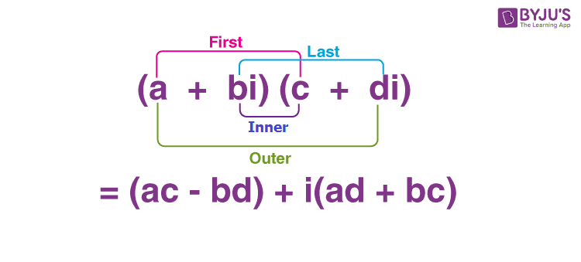
→compare(): This function checks to see if the two numbers are equal or not and outputs the same information.
→main(): The main function calls the input function in a for loop that executes twice and utilizes a switch case in a while loop to prompt the user to either perform any of the above operations or quit.

3. Explain the Importance of the approach followed by you
The usage of functions for each task makes the code more efficient and easier to understand. It allows for a clearer solution to the switch case inside the infinite while loop, which makes the user’s experience a lot more seamless.
Program code and Output screenshots:
CODE:
#include <stdio.h>

void input(int index);
void add();
void subtract();
void multiple();
void equality();

int nums[2][2];
int result[2];

int main() {
int option;
int stop = 0;

for(int i=0; i < 2 ; i++){
printf("Input the values of number %d:\n", (i + 1));
input(i);
}

while( !stop ){
printf("\n\nSelect an option to execute the associated operation:\n");
printf("[1] Add\n[2] Subtract\n3] Multiple\n[4] Compare\n[5] Exit Program.\n");
printf("Option: ");
scanf("%d", &option);

switch(option){
case 1:
add();
break;
case 2:
subtract();
break;
case 3:
multiple();
break;
case 4:
equality();
break;
case 5:
printf("Exiting Program.\n");
stop = 1;
break;
default:
printf("Enter a valid option.\n\n");
}
if (option == 1 || option == 2 || option == 3){
printf("The resultant complex number is: (%d) + (%di)\n", result[0], result[1]);
}
}
return 0;
}

void input(int index){
int real;
int imag;

printf("Enter the real part of the complex number: ");
scanf("%d", &real);

printf("Enter the imaginary part of the complex number: ");
scanf("%d", &imag);

nums[index][0] = real;
nums[index][1] = imag;
}

void add(){
result[0] = nums[0][0] + nums[1][0];
result[1] = nums[0][1] + nums[1][1];

}

void subtract(){
result[0] = nums[0][0] - nums[1][0];
result[1] = nums[0][1] - nums[1][1];
}

void multiple(){
result[0] = (nums[0][0] * nums[1][0]) - (nums[1][1] * nums[1][1]);
result[1] = (nums[0][0] * nums[1][1]) + (nums[0][1] * nums[1][0]);
}

void equality(){
if ((nums[0][0] == nums[1][0]) && (nums[0][1] == nums[1][1])){
printf("The complex numbers are equal.");
}
else {
printf("The complex numbers are unequal.");
}
}

OUTPUT IMAGES: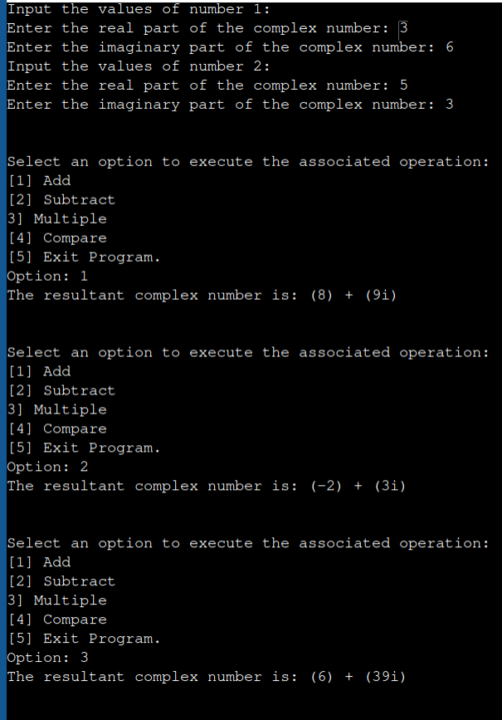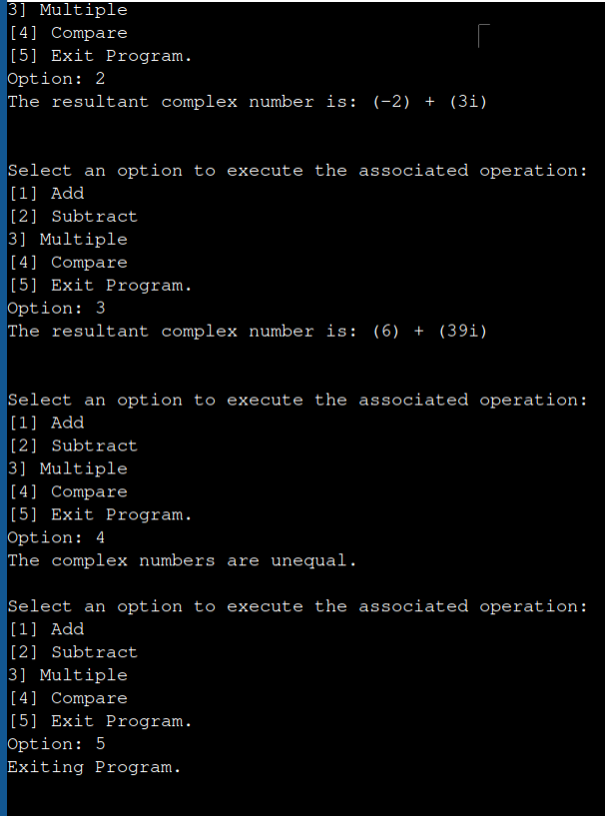

Conclusion:-
This experiment displays the usefulness of abstract data types to solve specific problems.

